A One-Day State level Seminar on Human Rights - Today’s Perspective
Organized by Govt. Mamit College, funded by UGC-NERO on 8/10/14 at C.V YMA Hall
A brief report

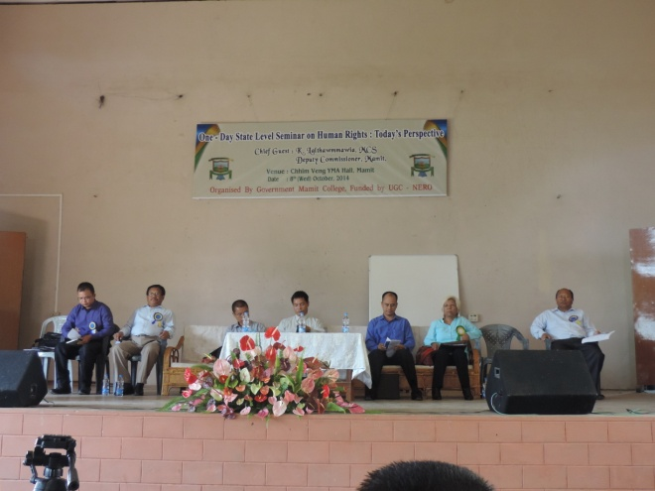

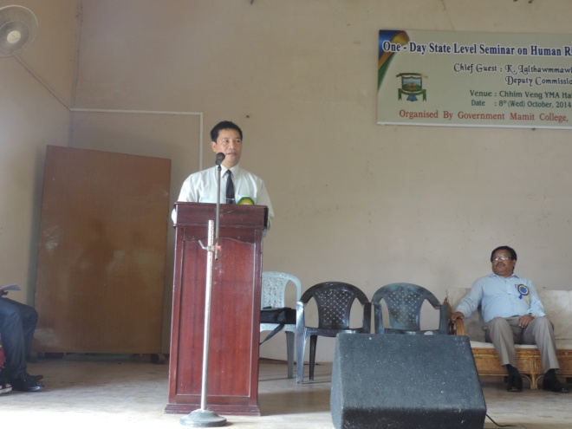
The denial of basic human rights to life has been rampant in the third world nations, and has become a global issue. Human rights and fundamental rights have become an integral part of the socio-cultural milieu known to all.
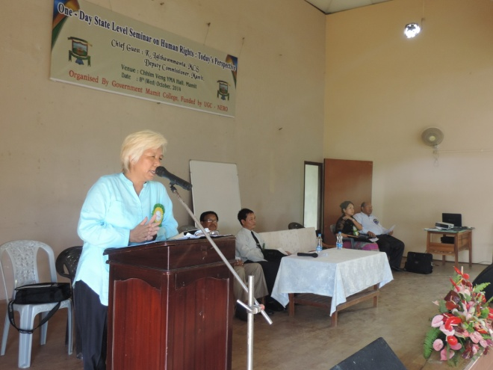
The importance and significance of Human rights have increased tremendously. As such, the University Grants Commission (UGC) has also encouraged Colleges and Universities in India to organize Seminars and Lectures on the topic of Human rights to make people aware and responsive on Human rights with the UGC funding.
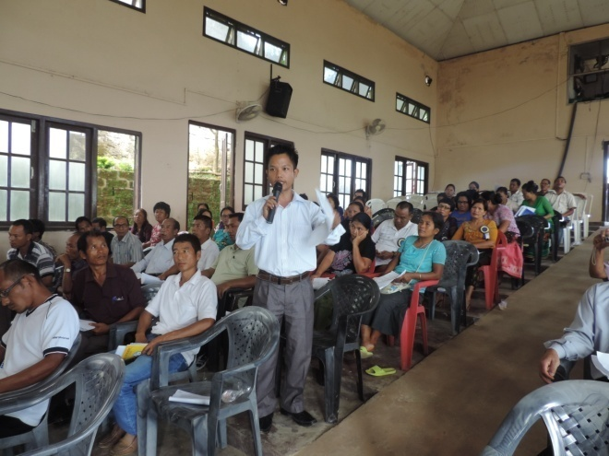

In this state level Seminar, renowned academician, social activist, judicial magistrate, and senior police officer have delivered their papers in different technical sessions. Students, NGO’s, media persons and different sections of the society have attended the Seminar. Many important queries were raised by the participants. Every query was answered very well by the resource persons. The Seminar was found to be successful and significant as because violation of Human rights and its related
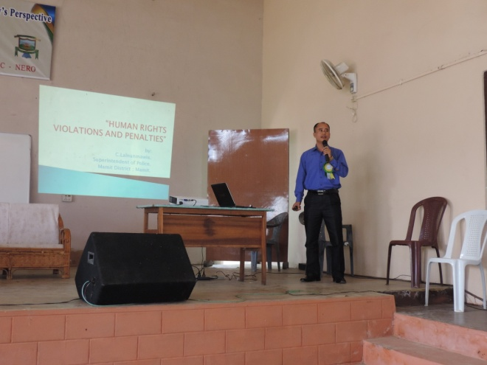

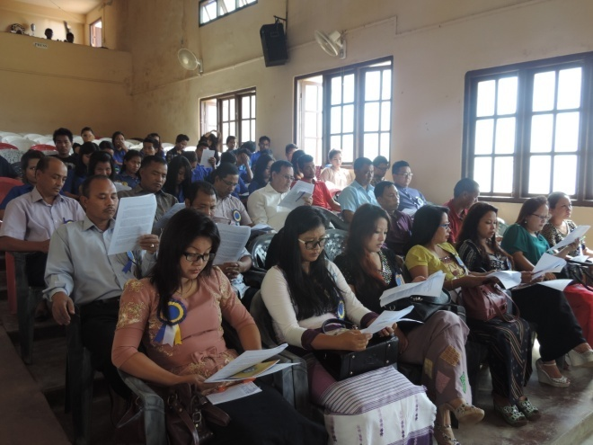
Problems; and its effect on Mizo society have deliberated upon. Also, feedback and different comments have showed that the Seminar was successful.

The Resource person and their respective topics are as follows:
- Dr. J. Doungel, : “Origin, Growth & Evolution of Human Rights”
Associate Prof. & HOD Pol Sc. MZU
- Vanramchhuangi : “Human Rights & NGO”
Activist Human Rights, Aizawl
- C. Lalnunmawia : “Human Rights Violation and Penalty”
Superintendent of Police,
Mamit District, Mamit
- Julie Lalrinzami : “Women and Child Rights”
Senior Civil Judge,
Mamit District, Mamit

