Seminar organized by
INTERNAL QUALITY ASSURENCE CELL (IQAC), GOVERNMENT MAMIT C0LLEGE

IQAC of our college organized a one-day State Level Seminar on 24th April 2015 at I&PR Conference hall, Mamit. The theme of the seminar was “Scenario of Higher Education and the role of the IQAC in Quality Improvement.” The Seminar was organized with a view to highlight the present scenario of higher education and importance of maintaining quality in higher education in the state. It aimed to boost the participants in bringing quality education in this remote corner of the country.

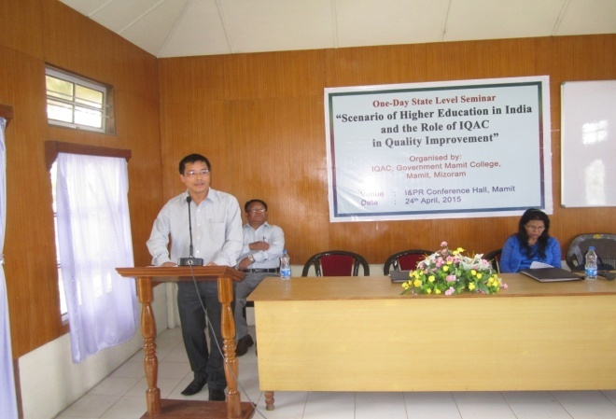
In the introductory speech, Dr. J.H. Zoremthanga, I/C, QAC, Directorate of Higher & Technical Education, Aizawl, drew attention on NAAC accreditation which is a mandatory for all the higher educational institutions on financial assistance from UGC and RUSA and it importance on quality education.
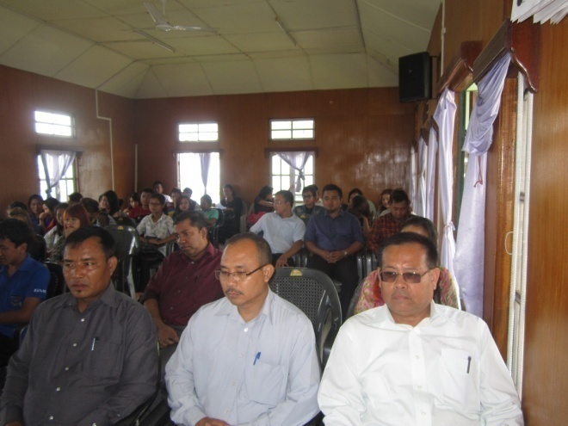

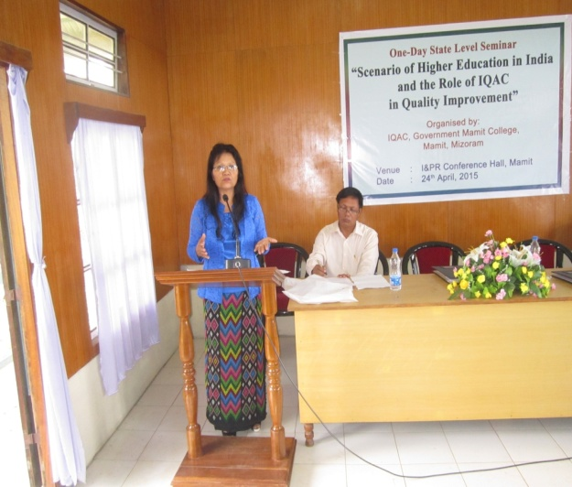
The seminar had two technical sessions. In the first session, there were two paper presenters. Professor Lalhmasai Chuaungo, Head, Dept. of Education, Mizoram University presented paper on “Scenario of Higher Education in India”. In her paper she highlighted the data on the growth of Universities, Colleges, types of colleges, gross enrolment ratio, stream-wise split of enrolment, number of teachers in colleges and universities and other facts and figures like global status of India in HEIs, etc.

The other paper was presented by Dr. A.P.K. Singh, Principal, Govt. Mamit College on “Changes in the Methodology and Criteria of Institutional Assessment and Accreditation by NACC.” He expressed the necessity of bringing quality in Higher education in the present context with the launching of New Economic policy in India where many private institutions has come into existence resulting tough competition within India and abroad. He also highlighted the new methodology of NAAC accreditation.
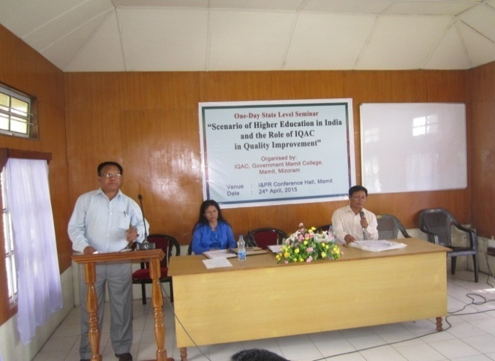

He also explained how to maintain graph of quality education at the college level. In his observation, good practices of an institution have taken importance for the accreditation by NACC.

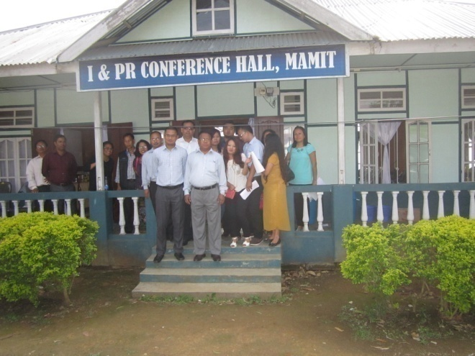

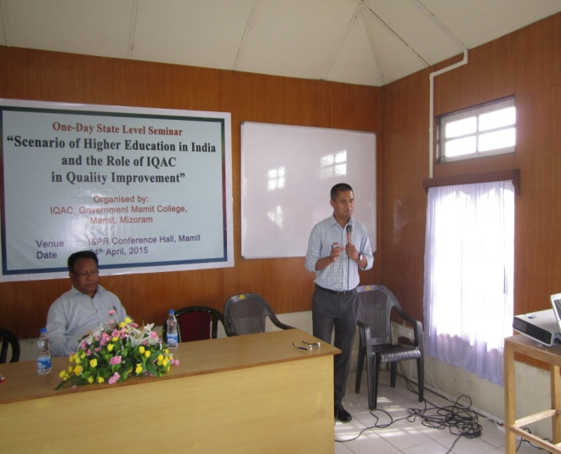
In the second technical session Dr. Laldinliana, Deputy Director, IQAC, Mizoram University, highlighted the view of the President of India on the importance to education, research and innovation in the higher education institutions. Dr. Laldinliana then emphasized the role of IQAC in the advancement of teachers’ career.
