ICCSR SPONSORED NATIONAL SEMINAR
ON
“FOOD SECURITY AND ECONOMIC DEVELOPMENT”

11th AUGUST 2015
I & P R CONFERENCE HALL; MAMIT

ORGD. BY:
DEPARTMENT OF ECONOMICS
GOVERNMENT MAMIT COLLEGE, MAMIT; MIZORAM

A BRIEF REPORT

The inaugural session was chaired by Mr. Kh. Arunkumar Singh, Associate Professor..Government Mamit College. He gave the welcome speech and introduction.
Mr. Ksh. Birlal Singh, Associate Professor,
Government Mamit College has given the
keynote address talking about more coverage
of food grain items in food security concept
and its relation to economic developmentThe
session came to an end with vote of thanks
by M.S.Dawngliana Hnamte, Assistant
Professor, Government Mamit College.

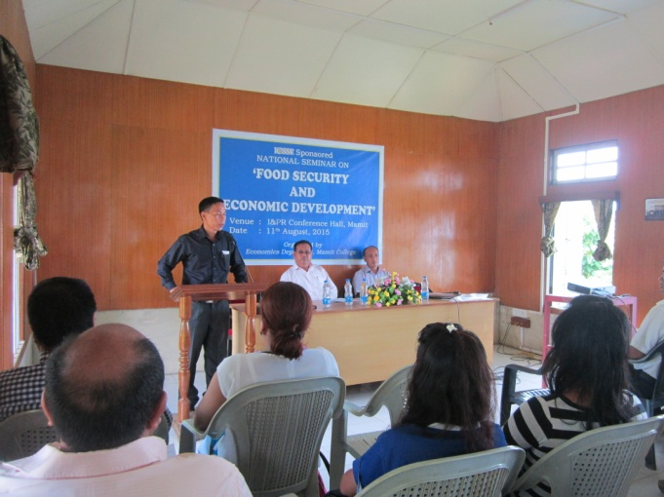

The first technical session was chaired by Dr. Lalnithar Zote, Associate Professor, Government Mamit College. The chair person invited the first resource person Dr. S.R. Zonunthara, Regional Director, IGNOU, Aizawl to present his paper on the theme: Food Security and Public Distribution System.

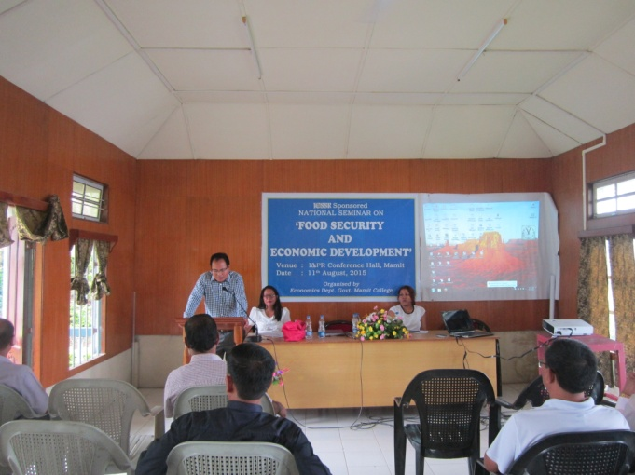

He highlighted his paper including:
- Ensuring foodgrains for all
- Price control as an important function of Public Distribution System (PDS)
- Private and Public Distribution System
He observed that food security at the macro level was successful but at the micro level was a failure.

The chair person called upon the second resource person Dr. Lalhriatpuii, Associate Professor, Department of Economics, Mizoram University to present her paper on the theme ‘Food Security in India – Challenges and Ways Forward’.

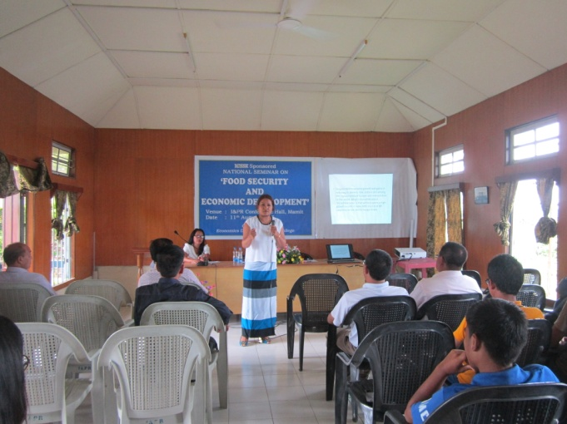

She presented her paper in Power Point Presentation (PPT). She talked about the shortcomings of Public Distribution System in India. Even though many missions and Act have been implemented in the country the actual beneficiaries were deprive of benefits.
She suggested ways forward for food security as below:
- The income criterion needs to be revisited and that estimation of poverty should not be made on criteria which is less than the minimum wage rate fixed by the state for agricultural labourer.
- The Government may also consider calorie intake per person per day as an indicator of poverty.
- Policy makers should consider the trade-off between increasing the quantity of food available and improving the quality of people’s diets.

The chairperson then invited the third resource person Dr. Prodipto Das, Assistant Professor, Assam University, Silchar to present his paper on the theme ‘Role of Information Technology in Food Security’. He also presented his paper in Power Point Presentation (PPT). He describes four dimensions of food security; physical availability of food; economic and physical access to food; food utilization and stability of the other three dimensions over time. He also make emphasis on IT’s role in achieving food security: Making food a global village; Climate information; Increasing Agri-based Production.

After the completion of three paper presentation chairperson opened for question hour and discussion

The second technical session was chaired by Bilal Ahmed, Associate Professor, Government Mamit College. The chairperson gave a short introduction and welcoming the resource persons. He called upon the first paper presenter Mr. Ksh. Birlal Singh, Associate Professor, Government Mamit College to present his paper on the theme ‘ Role of State and Other Agencies in Food Security and Economic Development’.

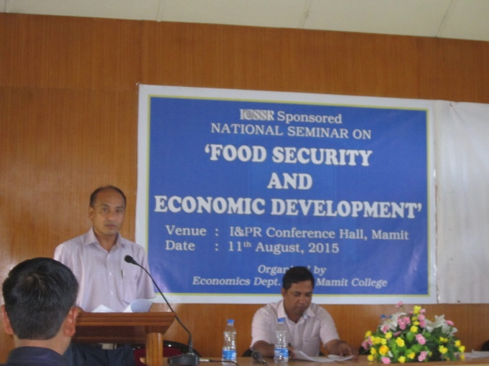

The resource person emphasized on the failure of distributive system in the country by saying that even though there is sufficient quantity of food items available the poorer section could not afford two meals a day in the country. He put up two approaches to achieve food security; one is by improving the income of the poor and another by increasing the domestic supply of foodgrains. He also suggested the possibility of economic development through food security. Government intervention and effective implementation of policies is needed for achieving food security which ultimately promotes economic development.

Chairman then invited second resource person, Mr. M.S. .Dawngliana Hnamte, Assistant Professor, Government Mamit College to present his paper on the theme ‘The National Food Security Act 2013: Salient Features and Evaluation’.

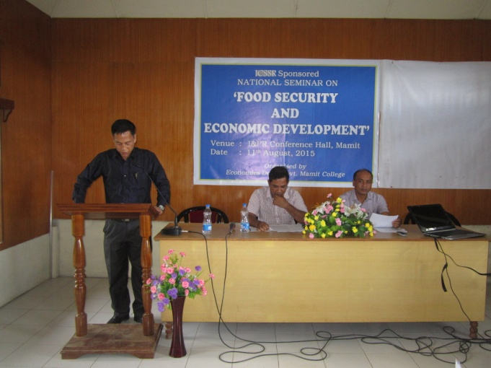
He starts with his presentation by commenting that despite of rapid economic growth that India has experienced, it has a long way to go redeem its million people from the grip of food insecurity and hunger.

Discussions and question hour followed after the presentation of papers.
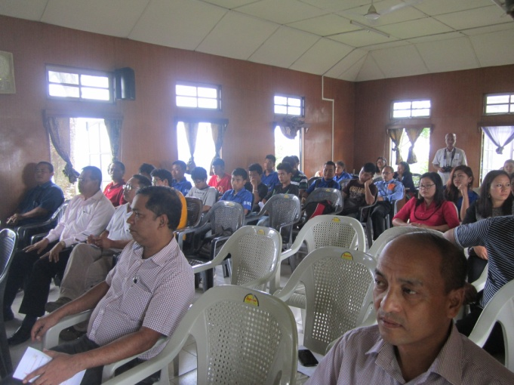

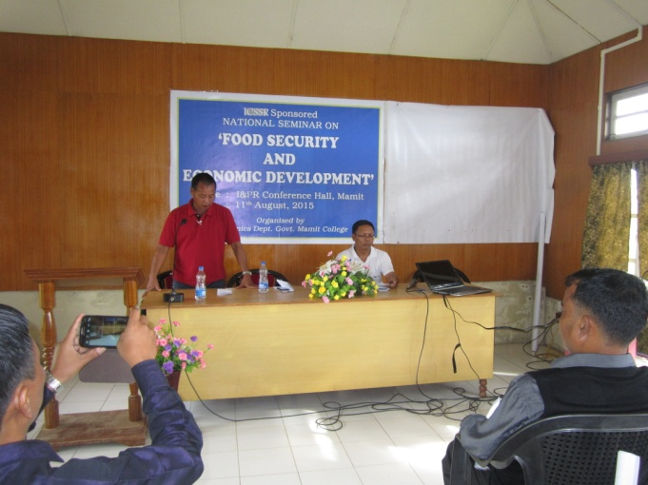

The closing function was chaired by Mr. Vanramropuia, Associate Professor, Government Mamit. Mr. Joseph Duhlian Associate Professor, Government Mamit College, thanked all the members who involved and participated in the seminar. With this, the chairman declared the seminar programme over.

