One-day State level Seminar on “ Siamliana Leh a Hlate”
Organized by:- Dept. of Mizo, Govt. Mamit college, Mizoram

The Department of Mizo, Govt. Mamit College, organized one-day State level seminar on “Siamliana Leh a Hlate” on 25th March 2015 at I&PR Conference Hall, Mamit. The Deputy Commissioner of Mamit district was invited as the Chief Guest.
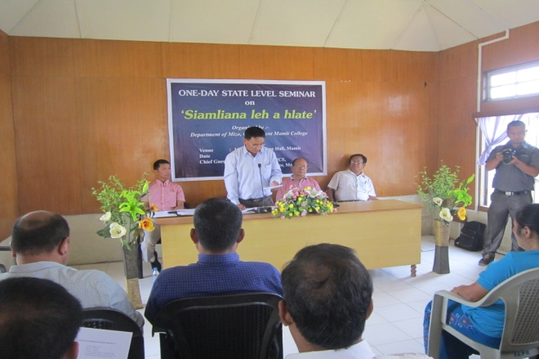
Siamliana was a poet who belonged to Mamit district, a part in the western side of the state. His contribution in the realm of literature of Mizoram is commendable and he is regarded to be one of the pioneers in this area. His works are being discussed at various levels. One of his songs is prescribed in the undergraduate course under Mizoram University.
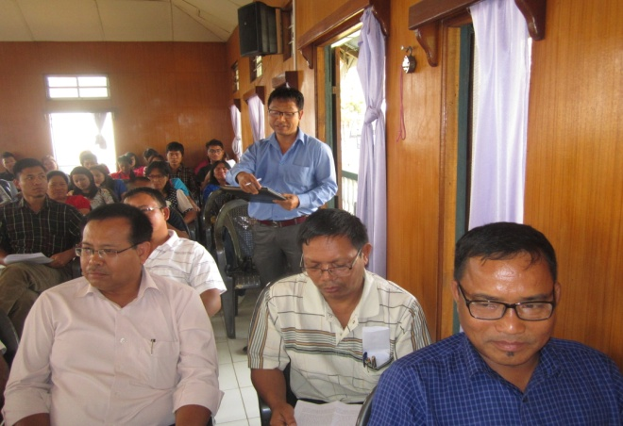

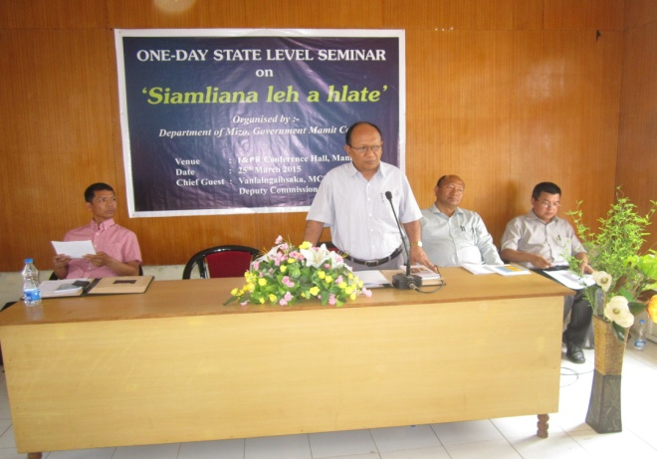
Prof. R. Thangvunga, Head, Dept. of Mizo, Mizoram University and Mr. Lalnunpuia Hrahsel, Teacher Govt. Higher Secondary School, Aizawl, were invited as resource persons. Prof. Thangvuanga analyzed the works of Siamliana with a deconstructive approach and explained their relevance in the present society of Mizoram. Mr. Lalnunpuia traced the different stages of the life of Mr. Siamliana and how these stages influenced his poetry.
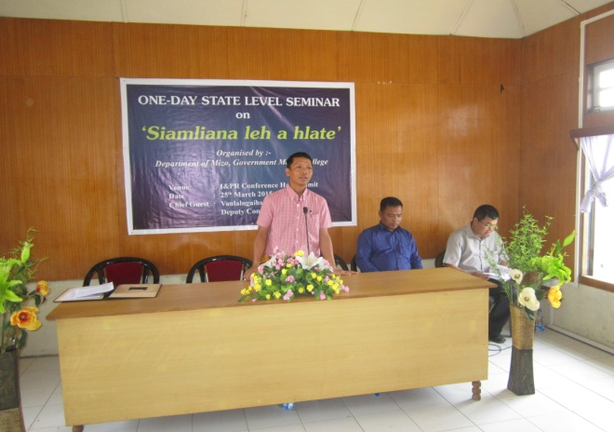
The Seminar was quite successful with a very good interactive session.

