A Two-Day State level Seminar on Political Parties in Mizoram: Their role in the socio-economic development of the State
Organized by Dept. of Political Science, Govt. Mamit College, funded by UGC-NERO on 12 & 13/August/2015 at I & PR Conference Hall Mamit
A brief report

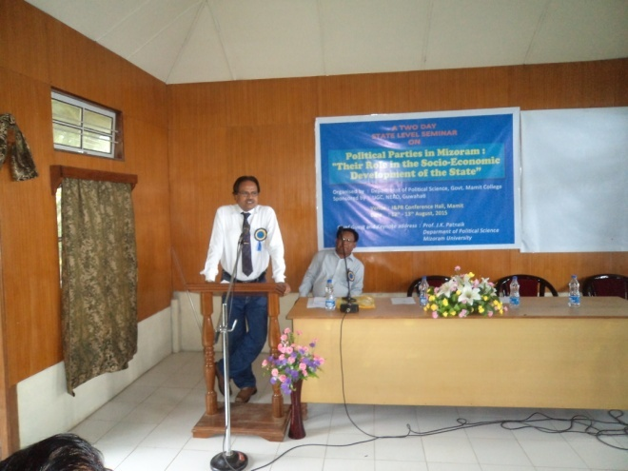
Today, most of the countries in the world have followed democratic form of Government. Political Parties are indispensable parts for the success of democracy, without which no-popular government can be formed because the citizens have very limited choice and rights under communist and military regimes.
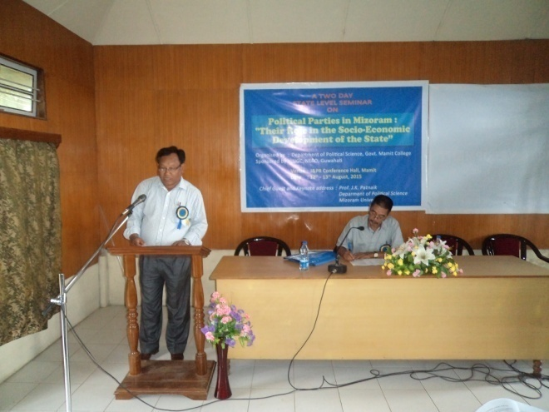
Hence, political parties are highly responsible for the socio-economic development as well as the successful functioning of the democratic States. In today’s world, the measurement of the quality of educational institutions is quite different compared to the past. Organizing seminar, workshop etc. have become an important component of quality education. As such, the University Grants Commission (UGC) has encouraged Colleges and Universities in India to organize Seminars and Workshops on different themes and topics with the UGC funding for the improvement of academic activities in India.
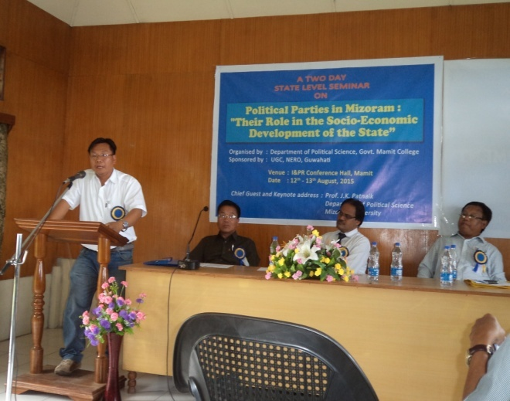
In this state level Seminar, renowned academicians and scholars across the State have delivered their papers in each technical session. Participants from different Colleges, Students, NGO’s, media persons have attended the Seminar.

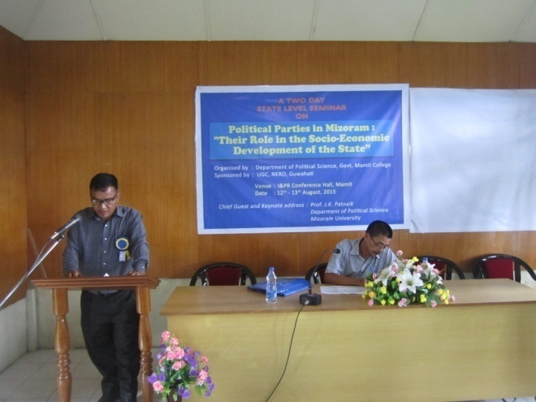
Many important queries were raised by the participants and all were answered by the resource persons. Half an hour time was allotted for discussion in each technical session.
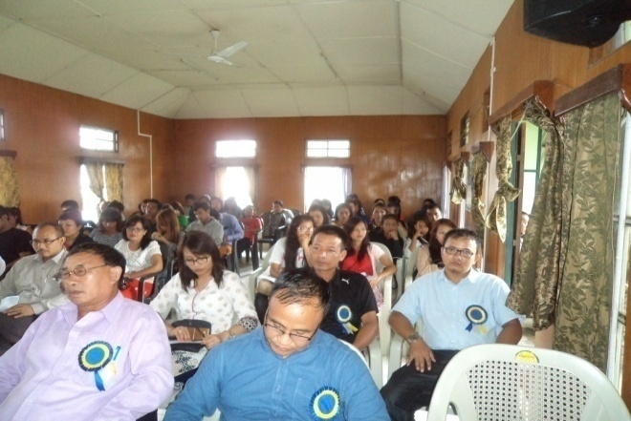

Feedback and different comments have revealed that the Seminar was successful.
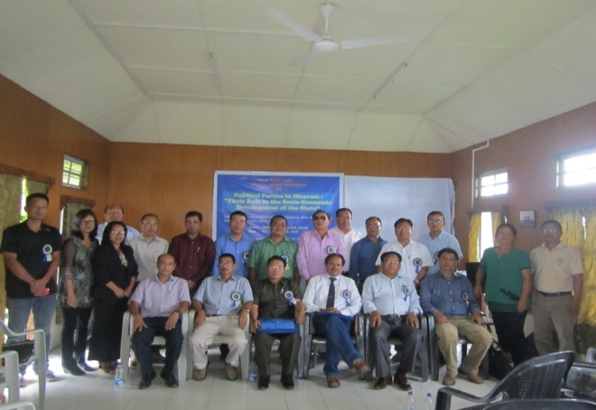

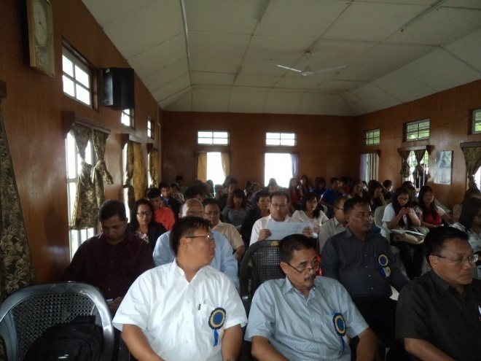

The Resource person and their respective topics are as follows:

Theme : "Origin of Political Parties in Mizoram ; A theoretical perspective"
Resource Person : Dr. Ayangbam Shyamkishor, Mizoram University
Theme : "Electoral Performance of Mizo Union and its impact in Mizoram"
Resource Person : Dr. Paul Songhaulal Songate, Associate Professor, Govt. Saitual College
Theme : "Voters perception of Election Manifesto"
Resource Person : Lalmalsawma Khiangte, Assistant Professor, Govt., Zawlnuam College

Theme : "Emergence of Political Parties in Mizoram"
Resource Person : Konjengbam Chandra Kumar Singh, Associate Professor, Govt.Khawzawl College
Theme : "Village Council Election (1954-2015)"
Resource Person : Dr. J. Zahluna, Associate Professor, Govt. Johnson College
Theme : “Political Consciousness – Road to Democratic System of Government.
Resource Person : Dr. Chawngsailoa, Associate Professor, Govt. Aizawl College
Theme : “Opposition Parties ; Benefits and challenges in building of Democratic good Governance in Mizoram’
Resource Person : Lalsangzuala Khiangte, Associate Professor, Govt. Aizawl College
Theme : “Political Consciousness and the birth of Mizo Union Party”
Resource Person : Dr. K. Vanlalmawia, Principal, Govt. Johnson College.
Theme : “Electoral performance of the BJP in the State Assembly” Elections in Mizoram during 1993-2013"
Resource Person : Dr. A.P.K. Singh, Principal, Govt. Mamit College

Theme : “Elections and Political Parties in Mizoram : An Over view of Mizoram Legislative Assembly Election”
Resource Person : Joseph C. Lalremruata, Assistant Professor, Govt. Mamit College.
Theme :“Emergence of MNF Party”
Resource Person : H. Ramdinpuia, Associate Professor, Govt. Mamit College
Theme : “National Parties in Mizoram”
Resource Person : Zothanpuii Chhangte, Assistant Professor Govt. Mamit College

